PHASE 1
Project Specification Document

Invigilation Process – Examiner’s Magnifier

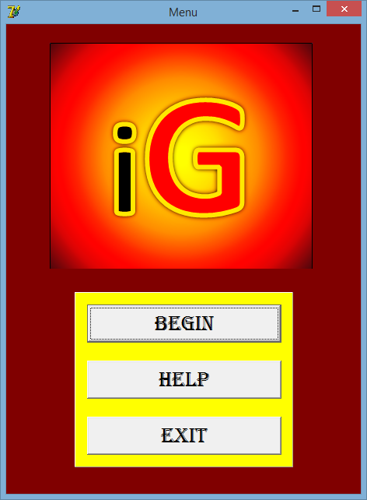

Developed by Tony Guo

Signoffs
Phase | Teacher | Date | Signature
1) Project Specification | Mrs. Niebuhr
Table of Contents
1. Summary 3
2. Project Goals, Justification, and Success Criteria 3
2.1 Project Goals 3
2.2 Justification 3
2.3 Success Criteria 3
3. Features of the program 3
3.1. Specifications of Program Functions 3
3.2. Specifications of User Interface 4
3.3. Specifications of Help 4
3.4. Specifications of Data Storage 4
4. Security Requirements 4
5. Data Conversion Requirements 4
6. Performance and Response Time Requirements 5
7. Hardware, Software and Installation Requirements 5
8. Localization Requirements 5
9. Testing Requirements 6
10. Data Archival, Backup and Recovery Requirements 6
11. Reporting Requirements 6

1. Summary
Every school has exams that students write once or twice a year. Teachers are needed to invigilate these sessions and this often takes lots of time to organize. I’ve decided to create an Invigilation Processor which will help school organizers to manage and create the invigilation schedules for all teachers. This will not only make it much more easy for school organizers to organize the invigilation, but also make it very accurate without any errors.

2. Project Goals, Justification, and Success Criteria
2.1 Project Goals | 2.2 Justification
Able to extract from and to files. | Get desired input and output.
Simplicity. | Easy to use and fun for organizers to use.
Professional look. | Make it look like a high-quality program that is well thought-out and considered a good program.
Speed and efficiency. | Fast and time-efficient.
Summary of inputted data. | Invigilator manager knows how many hours to allocate teachers.
Tools and help to make the invigilation schedule. | When making the schedule and invigilator maker gets stuck, user can be helped.
Easy navigation. | Users find the program user-friendly.

2.3 Success Criteria
The program will be a success if it can:
- Get input files from user via:
  - Manual – input
  - Microsoft Excel
- Get all the input files and extract all the data accurately.
- Create a summary of the inputted data to assist invigilator maker.
- Output form is a form with tools and visual to help the invigilator to make the schedule.
- Program works and runs.

3. Features of the program

3.1. Specifications of Program Functions
The program will be able to do the following:
- Get all the input of the excel files.
- Extract all the data and puts all the data into classes.
- Summaries the data.
- Gives a platform where all the invigilators can be seen and tools can be used to make the schedule.

3.2. Specifications of User Interface
The user-interface will have the following:
- Input interface where users can input data manually or load a file.
- Output interface where all final input data is displayed.
- Help interface to display help for each form.
- Summary interface to display the summarized info.
- Splash screen to look professional.
- Front page to access the input and help.

3.3. Specifications of Help
The following help features will be available:
- Help on each screen/form with richedits.
- Guidelines on the interface to guide users on what to do.
- Pop-up messages to guide user and for ease of access.
- Lots of defensive programming and show messages.

3.4. Specifications of Data Storage
The following data storage will be available:
All data is stored in the Input Folder and are mostly excel files:
- Staff Pictures 2015 folder
- Exam June 2015
- Extra Time Kids Note.txt
- Extra Time Learners 2015.txt
- Important Dates 2015.xlsx
- Staff 2015.xlsx
- Subjects 2015.xlsx
- Totals for Subjects 2015.xlsx
One file will be stored in Output Folder:
- Log.txt

4. Security Requirements
- Anti-virus on computer.
- Firewall on computer.
- Keep files organized and all in a single folder for each separate invigilation.
- Internet is not needed for the processing so when processing, don’t be online.

5. Data Conversion Requirements
Normal Data Conversions:
String to Integer : StrToInt – String to Integer
String to Currency: StrToCurr – String to Currency
Integer to String: IntToStr – Integer to String
Date to String: DateToStr – Date to String

ADOTable Conversions:
ADOTable.FieldByName(‘’).AsString: String
ADOTable.FieldByName(‘’).AsCurrency: Currency
ADOTable.FieldByName(‘’).AsInteger: Integer

ADOQuery Conversions:
ADOQuery.FieldByName(‘’).AsString: String
ADOQuery.FieldByName(‘’).AsCurrency: Currency
ADOQuery.FieldByName(‘’).AsInteger: Integer

6. Performance and Response Time Requirements
Performance:
Program works perfectly although during startup of application, user may experience a slight delay due to lots of code running during Form Create from many forms. State of the art interfaces will be experienced at relatively fast speed.

Response Time:
Programs response time is top notch due to built-in responses when data has been given to the application. User can take his/her time to give data in and the program will wait on the user’s time comfort. When a certain action has taken place and no visible changes can be seen, a message will pop up telling you the action was successful.

However, during the processing phase, the program may take a short amount of time due to the huge amount of documents needed to be processed and then outputted.

7. Hardware, Software and Installation Requirements
Screen Size
- A minimum of 1024x600
Operating Systems
- Windows XP SP3 and newer
- Mac OSX 10.6 and newer
- Linux – chromeOS
Computer Speed and Processor
- 1GB of RAM
- 2GHz processor
- Use a computer 5 years old or newer
Internet Speed
- Minimum speed of 512kbps
Software needed:
- Mircosoft Access 2002/2003
- Notepad

8. Localization Requirements
Language must be set to English.
Country must be set to South Africa to use the currency – Rand.

9. Testing Requirements
Testing should ensure that:
- Files are able to be inputted.
- Inputted data can be retrieved and displayed.
- A summary can be generated.
- Outputted interface will display tools and invigilator visuals to assist in the making of the invigilation schedule

10. Data Archival, Backup and Recovery Requirements
All input files and output files must be kept in the single folder the invigilation is to be worked on. Input files must be backed up so that if data is lost during processing, the process can start again. Output files should be archived for later access as hard copies will be printed and space on the computer will be needed so that users don’t get confused which invigilation they are busy with.

11. Reporting Requirements
Program is used to assist in the making of the invigilation schedule and so no reports will be generated. An interface where it will help the invigilation maker keep track of all the invigilators with their number of hours invigilated and tools when they are stuck.

